A Seminar Report on

# “HAMMING CUT MATCHING ALGORITHM”

At



“Bhagwan Mahavir College of Computer Application”,

Bharthana - Vesu, Surat

As A Partial Fulfilment for The Degree Of

Bachelor of computer Application

# 2024-25

|  |  |
| --- | --- |
| **Guided By** | **Submitted By:** |
| Asst. Prof. Krupa D Patel | Mr. Singh Amit S. |

Bhagwan Mahavir College of Computer Application

Bharthana - Vesu, Surat

Affiliated With



Bhagwan Mahavir University, Surat, Gujarat, India



**BHAGWAN**

**MAHAVIR**

**COLLEGE**

**OF**

**COMPUTER**

**APPLICATION**

*Certificate*

This

is

to

certify

that

the

seminar

entitled

“

**HAMMING CUT MATCHING ALGORITHM**

”

has

been

submitted

by

**SINGH**

**AMIT**

**S.**

**Enrollment**

**No.**

**2202020101833**

at

**Bhagwan Mahavir College of Computer Application**

as a partial fulfilment of the

requirement

for

the

degree

of

**Bachelor**

**of**

**Computer**

**Application**

for

the

academic

Year 2022

-

25.

**Place:**

**BMCCA**

**,**

**Surat**

**Date:**

**Asst.**

**Prof.**

**Krupa D**

**Patel**

**Asst.**

**Prof.**

**Dr.**

**Hetal**

**Modi**

**(**

**Seminar**

**Guide,**

**BMCCA)**

**(**

**Program**

**Head)**



**INDEX**

|  |  |  |
| --- | --- | --- |
|  | **Topic** | **Page No.** |
| 1. | Introduction of Hmming Cut Matching Algorithm | 1 |
| 2. | Why is it Important ? | 3 |
| 3. | Explanation of Hamming Distance | 3 |
| 4. | Working of Algorithm | 8 |
| 5. | Flowchart to Illustrate | 9 |
| 6. | Biometric System | 10 |
| 7. | Error Detection & Correction | 11 |
| 8. | Data Analysis | 12 |
| 9. | Advantages | 13 |
| 10. | Limitation | 14 |
| 11. | Implementation | 15 |
| 12. | Comparison with other Algorithm | 17 |
| 13. | Future Trends | 18 |
| 14. | Case Studies | 20 |
| 15. | Real-World Scenario | 20 |
| 16. | Conclusion | 21 |
| 17. | References | 22` |

# Acknowledgement



We Are Greatly thankful to Our Principal **Dr. Vikram Kaushik , Bhagwan Mahavir College Of Computer Application (BCA)**, Vesu for giving us the opportunity to develop the seminar. Then our humble thanks to all professors and staff members of our college for the cooperation and keep interest extended by them throughout our degree course. It is the base that they have built, which sustains such good job.

We deeply own our gratitude to our seminar guide **Asst. Prof. Krupa D Patel** and other faculty members for their kind help throughout this seminar, which ensured that the missing paces were found and put in place. We have no word to express our guide and other faculty without their moral supports and encouragement.

Finally, we are thankful to all the individuals who are not included here, but who have rendered their cooperation, little or more, directly in the course of development of this system & preparation of this document.

**Thanks to All**

Mr. Singh Amit S.

## HAMMING CUT MATCHING ALGORITHM

### INTRODUCTION

### 1.1 Introduction of Hamming Cut Matching Algorithm : -

The Hamming Cut Matching Algorithm is a computational method used to compare and match binary strings or patterns by utilizing the concept of Hamming distance. The **Hamming distance** is defined as the number of differing positions between two binary strings of equal length.

This algorithm is particularly effective in identifying similarities or differences in binary data and is widely used in applications such as **biometric systems** (like iris or fingerprint recognition), **error detection and correction** in communication systems, and **data clustering**. By calculating the Hamming distance, the algorithm determines whether the compared data sets are sufficiently close to be considered a match or need further analysis. It is celebrated for its simplicity, speed, and accuracy in a wide variety of technical fields.

**1.2 History and origin of Hamming distance in computational fields.**

The concept of Hamming distance has its roots in the mid-20th century when Richard Hamming, a prominent mathematician and computer scientist, introduced it as part of his pioneering work in error detection and correction. Hamming's contributions emerged during his tenure at Bell Labs, where he tackled the challenge of improving communication systems, particularly in the presence of noise and transmission errors.

In the late 1940s, Richard Hamming developed a method for detecting and correcting errors in transmitted data. He created a family of error-correcting codes, now famously known as Hamming codes, which utilize the idea of measuring the difference between transmitted and received data to identify and fix errors. These codes introduced the Hamming distance as a metric for determining how many positions (or bits) in two binary strings differ. This metric became a foundational tool for analyzing binary data in digital communication.

The application of Hamming distance expanded beyond error correction to various computational fields. Its simplicity and effectiveness made it a key component in pattern recognition, data clustering, biometric systems (e.g., fingerprint and iris recognition), and even in fields like genetics and computational biology for comparing DNA and RNA sequences.

Over the decades, Hamming distance has remained a fundamental concept in computer science, serving as the basis for algorithms and systems requiring precise data comparison. Its legacy is a testament to Richard Hamming's ingenuity and his desire to solve practical problems in communication and computation. Today, his work continues to influence modern technology, proving its timeless relevance in both theory and application.

**1.3 Importance of the algorithm in data comparison and pattern recognition.**

The Hamming Cut Matching Algorithm holds immense importance in data comparison and pattern recognition due to its simplicity, efficiency, and accuracy in evaluating the similarity between binary data sets. In fields where patterns must be compared or categorized with precision, this algorithm serves as an invaluable tool.

**Data Comparison**

The algorithm excels in comparing binary strings by calculating the Hamming distance—the number of mismatched bits between two data sets. This simple yet robust metric allows for quick and efficient evaluation of similarities or differences, making it ideal for applications in error detection, data clustering, and classification systems.

For example:

* **Error Detection and Correction:**

In communication systems, the algorithm identifies discrepancies in transmitted data, enabling the detection and correction of errors for reliable data transmission.

* **Text and DNA Sequence Matching:**

It can efficiently compare sequences to identify similarities, making it useful in genetics and computational biology.

**Pattern Recognition**

In pattern recognition, the algorithm plays a crucial role in systems that require the identification or authentication of unique patterns, such as biometric features. By encoding patterns into binary strings and computing their Hamming distance, the algorithm enables fast and accurate recognition.

Examples include:

* **Biometric Systems:**

Used in iris, fingerprint, and facial recognition technologies to compare input patterns against stored templates in databases.

* **Machine Learning:**

Helps classify and cluster data points based on similarity, supporting predictive models and data analysis.

**1.4 Why Is It Important?**

The algorithm’s significance lies in its ability to perform precise and computationally efficient comparisons. Its straightforward approach minimizes complexity, making it accessible and applicable across various domains without requiring excessive resources. Furthermore, its versatility ensures that it can be adapted to solve diverse challenges, from securing communication systems to advancing biometric technologies and even contributing to scientific research.

1. **BASIC CONCEPT**
   1. **Explanation of Hamming distance with example**

**Hamming Distance: An Explanation**

Hamming distance is a simple yet powerful concept used to measure the difference between two binary strings of equal length. It is defined as the number of positions where the corresponding bits in the two strings are different. This metric is widely used in computer science for data comparison, error detection, and pattern recognition tasks.

**How Hamming Distance Works**

To calculate the Hamming distance:

1 Take two binary strings of equal length.

2 Compare each bit at the same position in both strings.

3 Count the number of positions where the bits differ.

Example 1:

**Comparing Binary Strings**

Imagine two binary strings:

String A: 1011101 String B: 1001001

Step-by-step comparison:

* Compare each position:
  + 1 vs 1: Match
  + 0 vs 0: Match
  + 1 vs 0: Mismatch
  + 1 vs 1: Match
  + 1 vs 0: Mismatch
  + 0 vs 0: Match
  + 1 vs 1: Match
* Count mismatches: There are **2 mismatches**.

**Hamming Distance = 2**

Example 2:

**Application in Error Detection**

Suppose a binary code was transmitted as 1100110, but the receiver got 1110110. Calculating the Hamming distance helps to detect errors:

Transmitted Code: 1100110 Received Code: 1110110

* Compare each bit:
  + 1 vs 1: Match
  + 1 vs 1: Match
  + 0 vs 1: Mismatch
  + 0 vs 0: Match
  + 1 vs 1: Match
  + 1 vs 1: Match
  + 0 vs 0: Match
* Count mismatches: There is **1 mismatch**.

**Hamming Distance = 1**

This mismatch reveals a single-bit error during transmission.

**Why Is It Useful?**

Hamming distance is an essential tool for:

* **Error Detection/Correction**: Ensures reliable communication by identifying where errors occurred.
* **Pattern Recognition**: Compares binary-encoded patterns, such as biometric data, to find matches or differences.
* **Clustering and Classification**: Groups or categorizes data based on similarity in machine learning and data analysis.

**2.2 Mathematical representation of Hamming distance.**

The **Hamming distance** between two binary strings of equal length can be mathematically represented as follows:

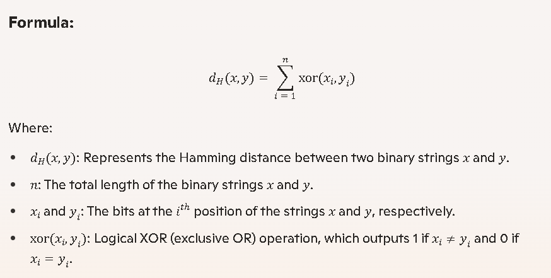

**Explanation:**

1. **Compare Corresponding Bits**:

For each position *i* in the strings *x* and *y*, check if the bits *xi* and *y*i are the same.

1. **Count Mismatches**:

Apply the XOR operation to determine mismatches. XOR outputs:

* + 1 if *xi*  ≠ *y*i
  + 0 if *xi*  = *y*i

1. **Summation**:

Sum up the XOR results across all nn positions to calculate the total number of differing bits (Hamming distance).

Example:

Let *x* = 1011101 and *y* = 1001001.

1. **Compare Bits**:

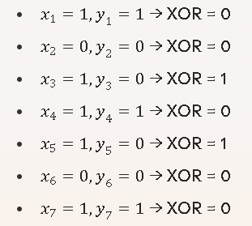

1. **Count XOR Results**:



1. **Sum Up XOR Values**:



**Hamming Distance = 2**

**2.3 How Hamming distance applies to data matching.**

**Hamming Distance in Data Matching**

Hamming distance is a fundamental concept used in data matching to measure the similarity or difference between two binary strings or data sets. Its simplicity and computational efficiency make it an ideal tool for various practical applications where data comparison is required.

**Applications of Hamming Distance in Data Matching**

**1. Biometric Systems**

Hamming distance is widely used in **biometric systems** such as iris recognition, fingerprint matching, and facial recognition. Biometric data is often encoded into binary templates, and the algorithm compares these templates to find matches. For example:

* In iris recognition, the Hamming distance is calculated between the input iris code and stored iris codes in a database.
* A small Hamming distance indicates a close match, which ensures accurate authentication of individuals.

**2. Error Detection and Correction**

In communication systems, Hamming distance is used to match transmitted and received data:

* By comparing the transmitted data with the received data, any differences caused by transmission errors can be detected.
* Error-correcting codes, such as **Hamming codes**, are designed using this metric to identify and correct these errors efficiently.

**3. Pattern Recognition**

Hamming distance plays an essential role in **pattern recognition** tasks where binary patterns are compared. Examples include:

* Recognizing text patterns by matching binary-encoded characters or images.
* Comparing DNA sequences in computational biology, where nucleotides are encoded as binary strings.

**4. Data Clustering and Classification**

In **machine learning** and **data analysis**, Hamming distance is used to cluster or classify data based on similarity:

* Binary attributes of data points are compared using Hamming distance to group similar points together.
* For instance, in genetic studies, data from different samples can be compared to identify closely related species or individuals.

**5. Database Searches**

When searching large databases of binary-encoded data, Hamming distance helps narrow down results by identifying close matches:

* In cybersecurity, it can be used to compare hashed passwords for secure authentication.
* In file deduplication systems, the metric detects duplicate files or closely related versions.

**Why is it Effective for Data Matching?**

* **Simple Calculation**:

It only requires a comparison of corresponding bits, making it computationally efficient.

* **Precise Matching**:

The exact count of differing positions ensures clear identification of similarity or dissimilarity.

* **Versatility**:

Its use extends across a wide range of fields and types of binary data.

1. **WORKING OF THE ALGORITHM**

**3.1 Step-by-step explanation of how the algorithm compares binary data.**

Here's a step-by-step explanation of how the Hamming Cut Matching Algorithm compares binary data, often used in biometric systems:

**1. Binary Data Representation**:

* + The patterns to be compared, such as iris codes or fingerprints, are first converted into binary representations.

**2. Segmentation of Binary Strings**:

* + Both binary strings (reference and candidate) are segmented into smaller blocks or regions to facilitate comparison.

**3. Calculation of Hamming Distance**:

* + For each block, the algorithm calculates the Hamming distance—the number of differing bits between two binary strings. For instance:
    - Binary String A: 110101
    - Binary String B: 100001
    - Hamming Distance: 2 (positions 2 and 5 differ).

**4. Threshold Evaluation**:

* + The calculated Hamming distances are evaluated against a predefined threshold. If the distance is below the threshold, the strings are considered similar; otherwise, they are different.

**5. Normalization (if applicable)**:

* + To account for variations or noise in the data, normalization techniques may be applied to ensure consistent results.

**6. Best Match Identification**:

* + If multiple candidates are being compared to the reference data, the algorithm identifies the candidate with the lowest Hamming distance as the best match.

**3.2 Flowchart to illustrate the Process.**

1. **Input Data**:

Start with two binary strings (e.g., iris codes) to compare.

1. **Preprocessing:**

Normalize the data to ensure consistency (e.g., handle noise or missing bits).

1. **Calculate Hamming Distance:**

Compare the binary strings bit by bit to count the number of differing bits.

1. **Threshold Check**:

Compare the calculated Hamming distance to a predefined threshold.

* If the distance is below the threshold, it's a match.
* If it's above the threshold, it's not a match.

1. **Output Result**:

Display whether the strings match or not.

1. **Applications**

**4.1 Biometric Systems:**

Biometric systems are widely utilized across various industries to enhance security, identification, and convenience. Here's an overview of their applications:

**1. Iris Recognition:**

**Applications**

* Used in airports and border control for secure and seamless identification.
* Employed in banking systems for secure transactions and access control.
* Adopted in healthcare for patient identification and record management.

**Advantages**

High accuracy and reliability due to the uniqueness of the iris pattern.

**2.Fingerprint Matching:**

**Applications**

* Integrated into smartphones and other devices for unlocking and secure access.
* Used by law enforcement for criminal investigations and identity verification.
* Deployed in attendance systems to track employee check-ins at workplaces.

**Advantages**

Ease of use and widespread familiarity among users.

**3.Facial Recognition:**

**Applications**

* Used in social media platforms for photo tagging and user verification.
* Employed in surveillance systems for public safety and crime prevention.
* Adopted in retail stores to enhance customer experience through personalized services.

**Advantages**

Contactless and non-invasive; works even in diverse environments.

**4.2 Error Detection and Correction: Communication systems and data recovery.**

Error detection and correction are essential in communication systems and data recovery to ensure the integrity and reliability of transmitted or stored data. Here's an overview:

**Error Detection in Communication Systems**

**1. Purpose** Identifies errors introduced during data transmission due to noise, interference, or other disruptions.

**2. Techniques**:

* **Parity Check**: Adds a parity bit to data to ensure the number of 1s is even (even parity) or odd (odd parity).
* **Cyclic Redundancy Check (CRC)**: Uses polynomial division to detect errors in transmitted data.
* **Checksum**: Calculates a value based on the data, which is verified at the receiver's end.

1. **Applications**: Used in network protocols, data transmission, and storage systems.

**Error Correction in Communication Systems**

* 1. **Purpose**: Not only detects but also corrects errors without requiring retransmission.
  2. **Techniques**:
* **Hamming Code**: Adds redundant bits to data to detect and correct single-bit errors.
* **Reed-Solomon Code**: Corrects burst errors and is widely used in CDs, DVDs, and QR codes.
* **Forward Error Correction (FEC)**: Sends redundant data to allow the receiver to correct errors.

**Data Recovery Techniques**

* **Logical Data Recovery**: Recovers data from undamaged storage devices using software tools.
* **Physical Data Recovery**: Involves repairing damaged hardware to retrieve data.
* **Backup Restoration**: Uses previously created backups to restore lost data.
* **File History**: Reverts files to previous states using operating system features.

**4.3 Data Analysis: Genetic sequencing, Text comparison, and Clustering algorithms.**

Data analysis in genetic sequencing, text comparison, and clustering algorithms involves distinct techniques tailored to their respective domains.

**Genetic Sequencing**

1. **Purpose**: Analyzing DNA or RNA sequences to understand genetic information, identify mutations, or study evolutionary relationships.
2. **Techniques**:
   * **Alignment**: Tools like BLAST align sequences to reference genomes.
   * **Variant Calling**: Identifies genetic variations, such as SNPs (Single Nucleotide Polymorphisms).
   * **Annotation**: Assigns biological meaning to sequences.
3. **Applications**: Used in personalized medicine, evolutionary biology, and disease research.

**Text Comparison**

1. **Purpose**: Identifying similarities, differences, or patterns in textual data.
2. **Algorithms**:
   * **Levenshtein Distance**: Measures the minimum edits (insertions, deletions, substitutions) needed to transform one string into another.
   * **Hamming Distance**: Counts differing characters in strings of equal length.
   * **Longest Common Subsequence (LCS)**: Finds the longest sequence common to two texts.
   * **Jaccard Similarity**: Compares the similarity between two sets of words or characters.
3. **Applications**: Used in plagiarism detection, document comparison, and natural language processing.

**Clustering Algorithms**

1. **Purpose**: Grouping data points into clusters based on similarity or distance.
2. **Types**:
   * **K-Means**: Partitions data into K clusters by minimizing intra-cluster variance.
   * **DBSCAN (Density-Based Spatial Clustering)**: Groups data points based on density, identifying outliers.
   * **Hierarchical Clustering**: Builds a tree-like structure of clusters.
   * **Gaussian Mixture Models (GMM)**: Uses probabilistic models to assign data points to clusters.
3. **Applications**: Used in market segmentation, image segmentation, and anomaly detection.
4. **Advantages and Limitations**

**5.1 Advantages**

These three advantages—simplicity, accuracy, and a wide range of applications—are essential across many fields, particularly when designing algorithms and systems. Here's how they apply:

**Simplicity**

* **Ease of Use**: Algorithms and systems designed with simplicity are easy to understand, implement, and maintain.
* **Reduced Resource Requirements**: Simpler models often require fewer computational resources and are quicker to execute.
* **Accessibility**: Simplicity ensures that non-experts can utilize the system effectively, broadening its reach.

**Accuracy**

* **Reliable Outputs**: High accuracy ensures that the results are consistent and trustworthy.
* **Minimized Errors**: Accuracy is vital in fields like medical diagnostics, data analysis, and communication systems where precision can be life-saving or critical to decision-making.
* **Improved Efficiency**: Accurate systems reduce the need for corrective measures, saving time and resources.

**Wide Range of Applications**

* **Versatility**: Algorithms and systems that can adapt to various scenarios are highly valuable. For instance:

* + **Genetic sequencing** applications span medicine, research, and agriculture.
  + **Text comparison** aids in plagiarism detection, language translation, and data mining.
  + **Clustering algorithms** are used in marketing, biology, and social network analysis.
* **Scalability**: They can be tailored to handle different data scales and complexities across industries.

**5.2 Limitation**

While many algorithms offer significant advantages, they do come with limitations. Let's address the ones you've mentioned specifically:

**1. Inability to Handle Large-Scale Non-Binary Data Directly**

* **Challenges**:

Algorithms like Hamming distance or Hamming-based methods are designed for binary data and struggle with complex, multi-dimensional datasets. Converting non-binary data into binary form often leads to information loss or increased complexity.

* **Workarounds**:
  + **Preprocessing**: Transforming non-binary data into a compatible format using feature engineering or encoding.
  + **Alternative Metrics**: Using algorithms like Euclidean distance, Manhattan distance, or cosine similarity, which handle multi-dimensional non-binary data directly.

**2. Computational Challenges in Large Datasets**

* **Challenges**: As datasets grow, the computational cost of algorithms increases dramatically, leading to scalability issues, slow performance, or memory exhaustion.
* **Workarounds**:
  + **Efficient Algorithms**: Algorithms like KD-tree, ball-tree, or Approximate Nearest Neighbors (ANN) optimize computation for large datasets.
  + **Distributed Computing**: Using frameworks like Apache Spark or Hadoop to divide computation across multiple machines.
  + **Dimensionality Reduction**: Techniques like PCA (Principal Component Analysis) or t-SNE (t-Distributed Stochastic Neighbor Embedding) reduce data complexity while retaining key features.
  + **Batch Processing**: Breaking the dataset into smaller batches and processing them sequentially or in parallel.

1. **IMPLEMENTATION EXAMPLES**

**6.1 Programming Implementation:**

**Python:**

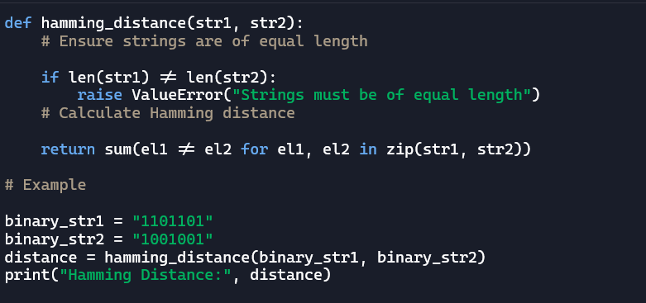

**C++:**

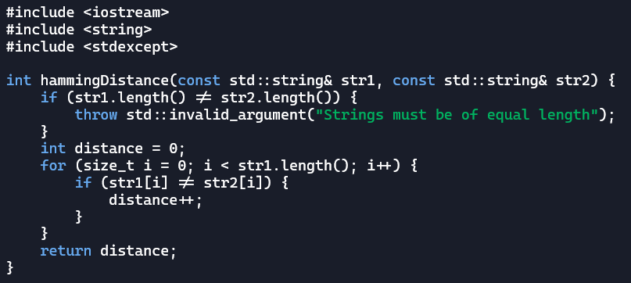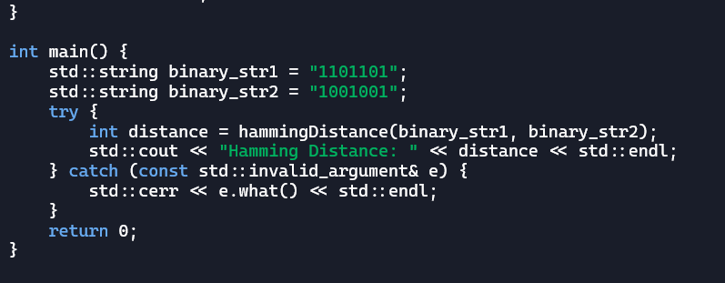

**6.2 EXAMPLE:**

**Compare DNA sequences and detect errors in data streams.**

The Hamming Cut Matching Algorithm indeed shines in these areas:

* **Compare DNA Sequences**:

In genetics, researchers use binary representations of DNA sequences (like converting nucleotides A, T, C, G into binary) to compare genetic patterns. The Hamming distance calculates the difference between sequences, helping identify mutations or similarities quickly.

* **Detect Errors in Data Streams**:

In digital communication, the algorithm is used to spot errors in transmitted data. If a binary data stream is corrupted during transmission, the Hamming distance can identify which bits are incorrect and enable correction, ensuring reliable communication.

1. **Comparison with Other Algorithms**

**7.1 Discuss Euclidean distance or Manhattan distance.**

Euclidean distance and Manhattan distance are both metrics used to measure similarity or dissimilarity between points, but they calculate it differently.

**Euclidean Distance**

* **Definition**: It measures the straight-line distance between two points in Euclidean space.
* **Formula**(in2D):  
  $$\sqrt{(x_2 - x_1)^2 + (y_2 - y_1)^2}$$
* **Applications**: Commonly used in clustering algorithms (like K-Means), image processing, and physics. It's ideal when you need precise spatial measurements.

**Manhattan Distance**

(also known as L1 Norm or Taxicab Distance)

* **Definition**: It measures the sum of the absolute differences of their Cartesian coordinates
* **Formula**(in2D):  
  $$|x_2 - x_1| + |y_2 - y_1|$$
* **Applications**: Widely used in grid-based problems, like navigating in city streets, and in machine learning for feature selection and classification.

**Comparison with Hamming Distance**

* **Hamming Distance** focuses on **binary strings** or sequences of equal length. It counts the number of positions where the corresponding elements differ.
* **Euclidean and Manhattan Distances** deal with **numerical or geometric data points** and can be applied in higher-dimensional spaces.
* **Metric Space**: All three are valid metrics and satisfy properties like non-negativity, identity of indiscernibles, symmetry, and triangle inequality.

**When to Use:**

* Use **Hamming Distance** for comparisons in error detection/correction and binary sequence matching.
* Use **Euclidean Distance** for problems involving physical distances or clustering in continuous spaces.
* Use **Manhattan Distance** for scenarios where movement is restricted to grid-like patterns (e.g., robotics or urban layouts).

1. **FUTURE TRENDS**

**How advancements in Computing and Machine learning may enhance the algorithm.**

Advancements in computing and machine learning are poised to significantly enhance the Hamming Cut Matching Algorithm.

1. **Quantum Computing**: Quantum algorithms could process binary data at unprecedented speeds, making the Hamming Cut Matching Algorithm even faster and more efficient for large-scale applications like biometric security and DNA analysis.
2. **Edge Computing**: With edge devices becoming more powerful, the algorithm could be optimized for real-time processing on IoT devices, enabling instant identity verification or error detection in decentralized systems.
3. **AI Integration**: Machine learning models could incorporate the algorithm for preprocessing binary data or as a metric for evaluating pattern similarity, improving the accuracy and efficiency of AI systems.
4. **Hybrid Algorithms**: Combining the Hamming Cut Matching Algorithm with other techniques, like neural networks or genetic algorithms, could create hybrid solutions tailored for complex problems.
5. **Sustainability**: Energy-efficient computing advancements could reduce the algorithm's carbon footprint, making it more sustainable for widespread use.

**Potential new applications in fields like artificial intelligence and cybersecurity.**

The Hamming Cut Matching Algorithm has exciting potential for new applications in artificial intelligence (AI) and cybersecurity.

**Artificial Intelligence**

1. **Feature Extraction**: The algorithm could be used in AI models to preprocess binary data, extracting meaningful features for pattern recognition tasks.
2. **Neural Network Optimization**: It might serve as a metric for evaluating similarity in neural network layers, improving the efficiency of training and inference.
3. **Reinforcement Learning**: The algorithm could help agents identify optimal actions by comparing binary representations of states and rewards.

**Cybersecurity**

1. **Biometric Authentication**: Expanding its use in iris recognition, the algorithm could enhance multi-modal biometric systems combining fingerprints, facial recognition, and voice patterns.
2. **Intrusion Detection**: It could be applied to detect anomalies in binary data streams, identifying potential security breaches or malware.
3. **Cryptographic Systems**: The algorithm might assist in verifying the integrity of encrypted data by comparing binary hashes.
4. **CASE STUDIES**

**Real-world scenarios where the algorithm has been applied successfully**

Example: Iris recognition systems in airports, banks, military and healthcare.

The Hamming Cut Matching Algorithm has been successfully applied in several real-world scenarios, particularly in biometric systems like iris recognition.

1. **Iris Recognition in Airports:**

The algorithm is used to enhance security and streamline passenger identification. By converting iris patterns into binary codes, it enables quick and accurate matching against a database, ensuring secure access and reducing wait times.

1. **In Banking Sector:**

Banks have adopted iris recognition systems powered by this algorithm for secure customer authentication. It eliminates the need for passwords or PINs, offering a unique and reliable method to access accounts and services.

1. **Military and Defense**:

The algorithm is employed in high-security environments to verify identities and restrict access to sensitive areas.

1. **Healthcare**:

In some cases, the algorithm has been used for patient identification, ensuring accurate medical records and preventing fraud.

**10.CONCLUSION**

**Summarize the key points discussed.**

1. **Overview**: The algorithm is designed to measure differences between binary strings, commonly used in applications like iris recognition and error detection.
2. **Applications**:
   * Biometric systems, such as iris recognition in airports, banks, and defense sectors.
   * DNA sequence comparison in genetics and healthcare.
   * Error detection and correction in data streams.
3. **Comparison**: It differs from other algorithms like Levenshtein distance, Euclidean distance, and Manhattan distance in its approach and ideal use cases.
4. **Future Trends**:
   * Optimization for edge computing and quantum systems.
   * Integration into AI pipelines and hybrid algorithm developments.
   * Expansion in cybersecurity for anomaly detection and cryptographic systems.
5. **Real World Impact**: The algorithm has demonstrated its versatility in enhancing security, reliability, and efficiency in various sectors.

**Reiterate the importance and versatility of the algorithm.**

The Hamming Cut Matching Algorithm is a cornerstone in computing and data analysis, celebrated for its **importance** and **versatility**:

1. **Importance**:
   * It offers a reliable and efficient method to measure differences between binary strings, a fundamental operation in fields like data integrity and biometric security.
   * Its speed and accuracy make it indispensable for applications requiring quick pattern recognition or error detection.
2. **Versatility**:
   * From securing airports and banks with iris recognition systems to analyzing DNA sequences in healthcare, the algorithm adapts seamlessly across diverse domains.
   * It serves critical roles in digital communication, identifying and correcting errors in transmitted data streams.
   * Future trends promise even broader applications, such as integration into AI pipelines, hybrid algorithm development, and quantum computing innovations.

**11.REFERENCES**

1. **Books:**

* *"Biometric Systems: Technology, Design, and Performance Evaluation"* by **James Wayman** , **Anil K. Jain** , and others, for a comprehensive guide on biometric matching algorithms.
* Pattern Recognition *Machine Learning"* by **Christopher M. Bishop**, which covers techniques relevant to this algorithm.

1. **Research Papers:**

* Articles from journals like IEEE Transactions on Pattern Analysis and Machine Intelligence, or Springer’s Pattern Recognition journal, often feature work on algorithms like this one.

1. **Online Resources:**

* Look for academic articles on platforms like Google Scholar or PubMed.